Waratah Public School Preschool Procedure
Providing a child safe environment
Reviewed: 28/4/2020
Education and care services regulation/s | NSW Department of Education policy, procedure or guidelines | Preschool Guidelines reference | School policy or procedure, where applicable
Regulation 168(2)(h)  84  103  105  109  115  S. 165  S. 166  S.167 | The following department policies and relevant documents can be accessed from the Early Learning section of the department’s website;  - Protecting and Supporting Children and Young People Policy PD/2002/0067/V02  - Working with Children Check Policy PD/2005/0264/V07  - Work Health and Safety (WHS) Policy PD/2013/0454/V01  - Child Protection – Allegations Against Employees Policy DOC16/1020544  - Student safety tools and procedures | p.40  p.45  p.49 | Teachers Handbook - Supervision
- Educators must maintain a ratio of one educator for each 10 children at all times. Educators inform each other if they are required to move to another space (toileting a child, bathroom break, answering the door etc.)

- Supervision is maintained throughout the day in all areas and a flexible supervision schedule in place to ensure all areas of the playground are supervised.

- To ensure potential hazards and risks are identified and managed, a daily indoor and outdoor check is undertaken by SLSO’s before children and families arrive at 9am.

- Storage shed doors should be closed when not supervised by an educator.

- An end of day check is to be conducted, in which the preschool sign in sheet is checked to ensure that all children have been signed out. The preschool rooms, including toilets and grounds should also be checked to ensure that all children have left the grounds. Front gates should only be locked once these checks have been completed.

- Risk assessments are reviewed annually for the preschool environment (indoor and outdoor) and activities offered to children. These are also reviewed if there are changes to the environment. These are stored both in the Preschool WH&S folder in the staffroom and digitally on the school’s common T:Drive.

- A cleaning schedule is developed for each classroom and labels for recording cleaning dates are placed on resource containers. A cleaning regime and toy cleaning procedure have been developed which outlines cleaning products and methods in detail.

- Educators understand their responsibilities as a mandatory reporter and have been shown the “Child Story” website. Educators discuss concerns with the preschool team/supervising teacher prior to making a report.

- Potentially hazardous products, including chemicals and medications are stored in locked storerooms. A chemical safety sign is located on storeroom doors.

- Safety data sheets for all chemicals are stored digitally in the preschool. A chemical register is also available.

- The sandpit is cleaned naturally through exposure to sunlight throughout each day. The cover is replaced before 3pm each day. Sand is topped up when required and replaced annually.

- Any WH&S issues must be immediately reported to the Principal and General Assistant (GA), added to the GA’s jobs register and a hazard form completed and handed to a member of the WH&S committee. Any issues which cannot be fixed immediately and pose a safety issue, must be cordoned off and the children kept away until the area/issue is fixed.

- A risk management plan should be developed for any ongoing WH&S issues.

- Certified soft fall surrounds the natural play equipment and sandpit and gymnastics mats are available for use when any equipment is higher than 600mm off the ground (Kidsafe NSW guidelines).

- For Moveable play equipment, a minimal falling space and impact area of 1500mm is required surrounding moveable play equipment items that measure 600mm or more above ground level. An impact area of 1500mm is required between each piece of equipment that is not linked (AS/NZS 4422). See Figure 1 below.

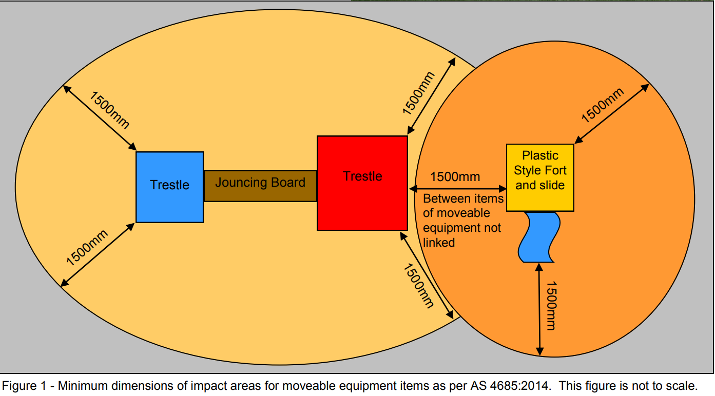
- A fire extinguisher (next to kitchen) and a fire blanket (inside the kitchen) are located in the preschool and fire alarms installed throughout the preschool.

- Power points are fitted with protectors whilst not in use and there are no double adaptors are in use. Electrical checks are conducted annually by external contractors.

- When animals are in the preschool, such as for show and tell or during the Responsible Pet Program, risk assessments are developed, and provisions put in place for any children who are frightened or have allergies. Children are asked to wash their hands before and after playing with/patting any animal.

- The KidSafe website is referred to before purchasing plants and for identifying any current poisonous plants in the environment. Educators consult with Greg Younger, Waratah Public School’s Horticulture-trained SLSO regarding any environmental concerns.

Evaluation
The preschool children and their families are protected from harms and hazards, as stated in the National Quality Standard, ‘At all times, reasonable precautions and adequate supervision ensure children are protected from harm and hazards (Element 2.2.1).’

Sources: All WPS Preschool procedures are based on information provided in the following documents;
- The Leading and Operating Department preschools Guidelines
- The Staying Healthy Guide - 5th Edition
- The Early Childhood Code of Ethics.
- National Quality Standard
- DoE Policies and procedures
- Waratah Preschool's Philosophy

Review
Management and staff will monitor and review the effectiveness of this policy at regular intervals throughout the year. Waratah Public School Preschool's Procedures must be reviewed and updated every 12 months or when changes are made to the environment. Due for Review in April 2021.

COVID 19 – Updated 28/4/2020

- A phased approach to attending preschool (starting with one day per week) will mean there are a smaller number of children at preschool each day, providing more space to spread out. It also helps to balance the varied needs of students and staff, their families, personal circumstances and workplaces. The flexibility of the approach means we can also respond quickly to any new spikes in the spread of COVID-19.
- Posters about COVID 19 symptoms and appropriate handwashing technique are displayed in the preschool. Posters supplied by the DoE can be accessed here:
- https://education.nsw.gov.au/inside-the-department/health-and-safety/risk-management/infection-control#Health3
- https://education.nsw.gov.au/inside-the-department/covid-19/school-staff/covid-19-poster-placement-guide
- More resources to support education about COVID 19 can be found at: - https://www.health.nsw.gov.au/Infectious/covid-19/Pages/resources.aspx
- Intentional teaching of good hygiene practices:
- wash hands on arrival at preschool
- wash their hands frequently with soap and water before and after eating and after going to the toilet
- wash hands before and after eating.
- cover their nose and mouth when they cough or sneeze, by coughing into their elbow. Disposal of used tissues and hand washing.
- avoid touching their faces
- limit physical contact when greeting people
- limit physical contact in the indoor and outdoor environment.

- Preschools have access to additional supplies of cleaning products, soap and hand sanitiser.

- NSW public schools are regularly and professionally cleaned. Enhanced cleaning is being implemented across all NSW public schools at this time.

- Preschools will continue to implement appropriate social distancing measures proportionate to health advice at the time, which is that social distancing for children is different than adults (Appendix B).

- Additional social distancing measures that can be implemented include:
- Staggered school drop off and pick up times – parents will be asked to sign in/out at the preschool gate and not enter the preschool.
- Smaller class sizes - Reduced children numbers each day while maintaining ratio of 1:10
- Social distancing markers on the ground in areas such as the bathroom.

- Signs indicating how many children can use an area at one time – for example 4 children in the sandpit at a time.

Sources:
https://education.nsw.gov.au/covid-19
https://education.nsw.gov.au/early-childhood-education/coronavirus
Appendix A – Effective Health & Hygiene Practices during COVID-19 Pandemic (DoE)
Appendix B – Social Distancing in Preschool (DoE)

