Waratah Public School Preschool Procedure
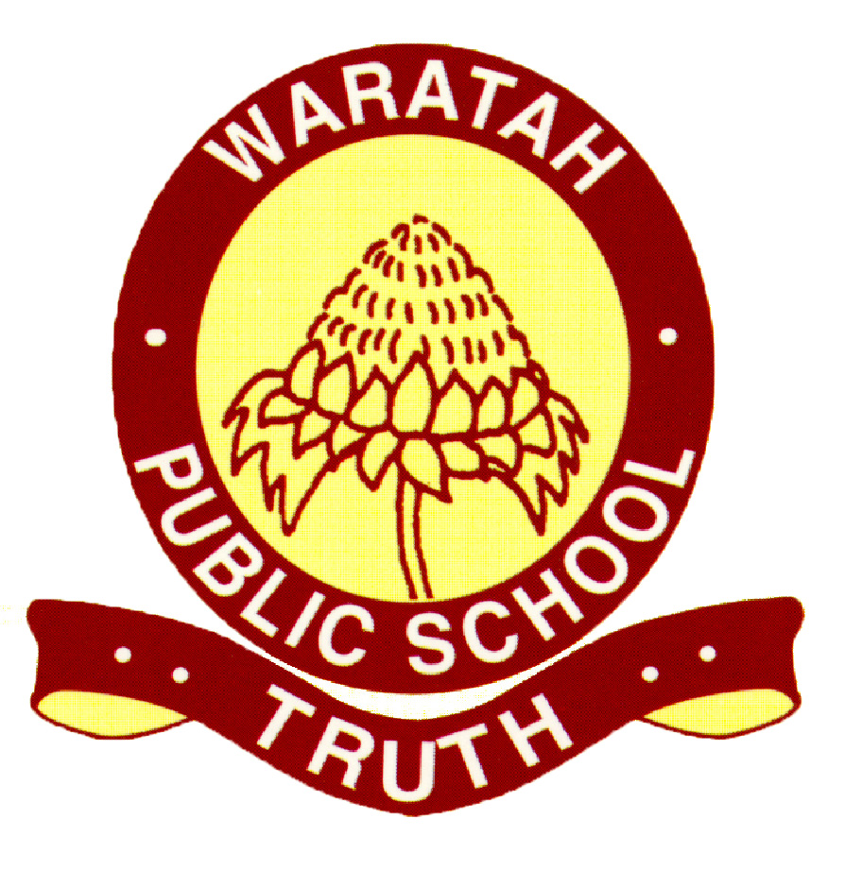
Toy Cleaning
Reviewed: 12/2/2020
Education and care services regulation/s | NSW Department of Education policy, procedure or guidelines | Preschool Guidelines reference | National Quality Standard | School policy or procedure, where applicable
Regulation 103 | The following department policies and relevant documents can be accessed from the preschool section of the department’s website;  - Work Health & Safety (WHS) policy | p. 34-35 | 2.1 | DoE COVID 19 Hygiene advice  (March 2020)
Resources;
- Staying Healthy Guide 5th Edition

This procedure has been developed to minimise the spread of bacteria and disease at Waratah Public School Preschool.

Implementation
- Children will be asked to wash their hands upon arrival as part of their morning routine, and when they come inside from outdoor play.
- Toys will be washed immediately if they have been sneezed on, mouthed or soiled and discarded if cleaning isn’t practicable or effective.
- All toys will be washed throughout each term, unless stated otherwise in the cleaning regime (For example, if they haven’t been used).
- Some toys can be washed by placing in a laundry bag and using the dishwasher. These can be dried by hanging the bag outdoors or placing on a mat in direct sunlight.
- Larger toys can be wiped over with any of the recommended cleaning products (listed below).
- Keep a record of the date toys have been cleaned (SLSO to complete).

Outdoor cleaning
- Outdoor toys are to be washed based on a roster and itemised list for each storage shed. Children can be involved in this process.
- Warm soapy water and drying in the sun is the most effective method.

Recommended Cleaning Products
- Detergent and water
- Eucalyptus/Tea Tree or Lavender oil (diluted in water 1 drop per 100ml water)
- Vinegar (diluted 1:10 in water)
- Lemon juice
- Water

Wooden Toys/Puzzles
- Wipe over with a damp cloth (Do not immerse in water)

Evaluation
We aim to provide a clean environment in order to reduce the spread of infection and disease and for all children and educators in attendance at our service.
All staff follow the DoE “Effective health and hygiene practices during COVID-19 pandemic” (attached here as an appendix item) correctly and inhibit the ‘chain of infection’.

Review
Management and staff will monitor and review the effectiveness of this policy at regular intervals throughout the year. Waratah Public School Preschool's Procedures must be reviewed and updated every 12 months. Due for review in February 2021.

