**Waratah Public School Preschool Procedure**

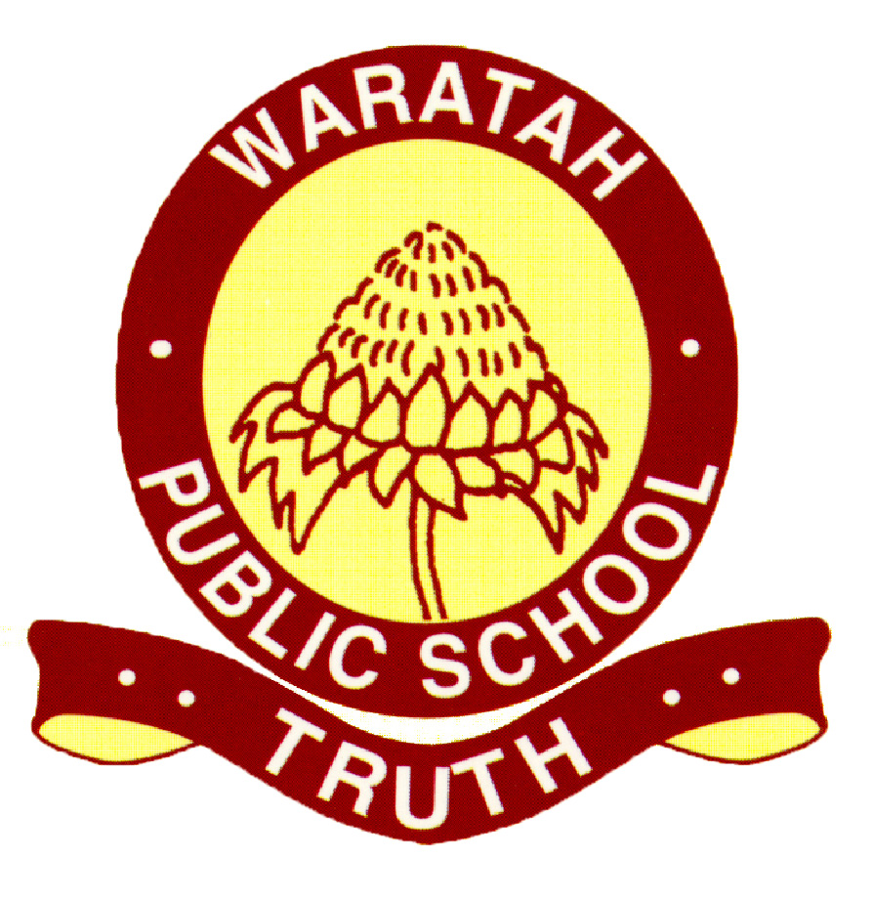

**Food and Nutrition**

**Reviewed: 18/9/20 Next Review: 18/9/21**

|  |  |  |  |  |
| --- | --- | --- | --- | --- |
| Education and Care Services National Law or Regulation | Associated department policy, procedure or guideline | [Preschool Guidelines](https://schoolsequella.det.nsw.edu.au/file/a240a1ff-d3e3-4883-92b4-a3591f4e12d7/1/leading-and-operating-department-preschool-guidelines.pdf) reference | Associated National Quality Standard | School policy or procedure |
| [78](https://www.legislation.nsw.gov.au/#/view/regulation/2011/653/chap4/part4.2/div1/reg78)  [79](https://www.legislation.nsw.gov.au/#/view/regulation/2011/653/chap4/part4.2/div1/reg79) | The following department policies and relevant documents can be accessed from the preschool section of the department’s [website](https://education.nsw.gov.au/teaching-and-learning/curriculum/preschool/policies-and-procedures);   * [*Nutrition in School’s* policy](https://education.nsw.gov.au/policy-library/policies/nutrition-in-schools-policy) * Staying Healthy Guide (5th Edition) * [NSW Food Authority](https://www.foodauthority.nsw.gov.au) 4-Hour/2-Hour Rule * [Eat for Health website](https://www.eatforhealth.gov.au/) * Munch and Move * Australian Dietary Guidelines | Pg. 36-37 | 2.1 | Healthy Canteen Procedure – Designated preschool menu |
| 1. Educators, parents, caregivers, and children should be aware of any child who suffers from a food allergy prior to enrolment (during pre-enrolment meeting). Educators should teach children and families about allergies and the importance of being vigilant with food handling and food bought to preschool. 2. Each child with a known allergy to food or other allergens, has a risk management plan developed to reduce exposure to known allergens. This information is shared with all staff during whole school induction and alerts are displayed in the preschool kitchen and casual folder. 3. Anaphylaxis ASCIA action plans with photos will be displayed in the preschool kitchen for any child known to suffer from allergies. This information will also be displayed in the casual teacher folder and information shared with duty staff. 4. In relation to children at risk of anaphylaxis or a food allergy,    * Depending on the trigger food, this can be managed by either asking the child with the allergy to choose a friend to sit with at a table away from other children, or if there are no trigger foods identified, the child can sit with the group and be closely supervised.    * All children will be explicitly taught about allergies and anaphylaxis and the importance of not sharing food and washing hands thoroughly.    * Lunches of other children will be monitored for trigger foods before being placed in the fridge/trolley. Any trigger foods will be put aside and stored separately from other lunches.    * Supervision during mealtimes will be closely monitored and children asked to space out more, washing hands as soon as they have finished eating. 5. Families provide information about their child’s dietary requirements based on religious or cultural beliefs as well as allergies in an additional information form, as well as during a parent teacher meeting prior to enrolment. This information is shared with all staff during a whole school induction, as well as during preschool staff meetings. 6. Educators need to consider the special dietary requirements of children from diverse cultural and religious backgrounds especially when engaging in cooking activities or special occasions. During special events or celebrations, such as birthdays, families are consulted to ensure that dietary requirements are met for all children. If visiting the school or going on an excursion, EpiPen’s are kept close by any child with known allergies or intolerances. 7. Families supply a packed lunch and afternoon tea. They can choose to send two separate lunch boxes, but children can choose what they eat at lunch and/or recess. Educators encourage parents to provide their children with food and drinks that are nutritious, adequate in quantity, varied and appropriate to the developmental needs of the child and consistent with the Australian Dietary Guidelines. 8. Families are provided with visual resources outlining ideas for a healthy lunchbox. They are given information which explains how to read a nutrition label and the recommended daily intact is highlighted for families. Families are informed via information sessions, conversations, social media and through the provision of brochures. Educators post nutritional information on Facebook and video demonstrations of healthy recipe ideas. 9. Chocolate, chocolate products, potato chips, lollies, sweet biscuits or cakes will be strongly discouraged at preschool. **EXCEPTION**: When a child celebrates a birthday, an allowance is made for the child to share this experience, including a cake, with their preschool friends. Any other activities/occasions will be classed as a ‘Red Food’ Day and will be limited to 6 times per year. Sandwich spreads such as honey and jam are high in sugar content, whilst peanut butter and Nutella contain nuts. These spreads are discouraged. 10. We develop relationships with families and have conversations regarding food selections. If a child brings any discouraged food items or sandwich spreads, educators place a *Good For Kids* lunch box note in the child’s lunch box. This is a reminder to parents about our healthy eating program and suggestions for healthier alternatives are offered. In some situations, the child may be given permission to consume their food, if this is the main food item and it does not pose a safety risk (ie. allergies). 11. Our preschool uses the Australian Dietary Guidelines to determine healthy and unhealthy foods and use the ‘Nutrition Information table’ on the back of food products to assist with discussions with families. 12. If a child comes to school without lunch, fruit and bread are available for lunches to be made and the school canteen is in currently operational each Wednesday, Thursday and Friday. 13. Children place their lunch boxes on the food trolley and an educator checks each lunch box, placing food that requires refrigeration in the fridge. Lunch boxes are provided to the children at lunch and recess and returned to the fridge if required. Insulated lunchboxes are unzipped by approx. 5cm to allow the cold air of the fridge to enter the lunch box. 14. Children bring their own bottle of water to preschool. This is stored in a way which ensures accessibility throughout the day, whilst maintaining a safe distance from other drink bottles. Belongings are labelled. 15. If a child does not bring a drink bottle, fresh drinking and cups are available for children to access, educators will ensure that safe drinking water is always available throughout the preschool day. During mealtimes, children will be asked to collect their drink bottles and encouraged to have a drink whilst eating. 16. Mealtimes should be a ritual and should be a relaxed and happy time with staff modelling appropriate behaviours and healthy eating practices. Children eat together either indoors or outdoors on a mat. There is a dining table that is used also. The mat encourages conversations about recycling, reusing, recycling, worm farms, composting, and food waste. Sometimes both groups eat together outside, whilst other times, individual classes eat in their own rooms. Discussions should be encouraged regarding healthy choices during mealtimes. 17. Children should be given choice over which food items they wish to consume and quantities. In maintaining respect for families and the children, any requests by family for children to consume particular foods first are considered on an individual basis. 18. Educators will teach children about nutrition during mealtimes, including food choices, hand washing and hygiene. These teachable moments are referred to as rituals that surround mealtimes. 19. Fruit Break will be offered daily if sufficient fruit has been donated on any given day. Parents have been asked to donate one piece of fruit per week to cater for this fruit break. 20. Educators must observe health and hygiene requirements in the preparation, storage, hygiene and handling of food, including the use of food handling gloves and tongs. 21. Posters should be displayed in kitchen and bathroom areas to ensure children and educators are aware of correct hand washing routines. 22. Preschool children can order lunch from the school canteen on Wed, Thurs, Fri. There is a separate canteen menu to ensure that we continue to meet healthy eating guidelines. The menu is available from the preschool and online via the QKR app. 23. Educators model healthy eating habits whilst eating with the children and follow the Healthy Eating Guidelines. Educators are completing the Munch and Move training to ensure that their practice and knowledge is current and based on research.   **Preparation & Handling**   1. All areas where food is stored, handled, and prepared must always remain clean and good hygiene and safety practices reinforced throughout the cooking activities. 2. When engaging in cooking activities with the children, educators must “take into account any dietary requirements of children" and cater for this, accordingly, including speaking with parents, if necessary.  * The Leading and Managing Department Preschool Guidelines provides a procedure as a guide for cooking activities with preschool children. * wash hands before and afterwards * wear disposable gloves when preparing food * do not handle food when ill * cover and seal any cuts or sores * wash fruit and vegetables thoroughly * replace cutting boards and washing up cloths regularly * use tongs or spoons when serving food * keep food covered until served * ensure children are never in the kitchen * food must be checked to ensure allergens are not present and discussed with the families of children suffering allergies.  1. Foods including meat, poultry, dairy, rice must be refrigerated upon arrival at preschool. Lunch boxes should be checked each morning and after lunch and recess, to ensure all foods required to be refrigerated, are stored correctly. 2. Cooked pasta or rice, if prepared fresh, can be left out of the refrigerator for a maximum of 4 hours from completion of cooking. After this time, it must be disposed of. If refrigerated within 2 hours of cooking, it is deemed safe to consume. NSW Food Authority <http://www.foodauthority.nsw.gov.au/rp/temperature-control> 3. Parents will have access to brochures and information which promotes healthy eating and lifestyles and reminders about food safety (temperatures and refrigeration) and healthy eating. 4. When heating food, a thermometer must be used to ensure that the food reaches a minimum temperature of 60®C but a recommended 70 ®C to kill any bacteria. The food must stay at this temperature for 2 minutes to ensure any germs are killed. 5. Any uneaten food that has been reheated must be disposed of immediately. Parents should be informed of how much a child has consumed. Food must not be reheated more than once. Refer to the NSW Food Authority [4hour/2hour rule](D://4_hour_2_hour.pdf) 6. The fridge must be checked each day to ensure a temperature of 3-5®C is maintained for chilled foods. This check must be recorded on the indoor environment checklist before 9am. | | | | |

|  |
| --- |
|  |