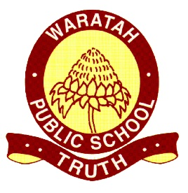
Waratah Public School Preschool
Observation and Educational Programming Procedure

Reviewed: 23/9/20 Next Review: September 2021
Education and care services regulation/s | NSW Department of Education policy, procedure or guidelines | Leading and operating department preschool Guidelines | School policy or procedure, where applicable
National Law Sections 323, 168  Regulation 168(2)(h)  73, 74, 75, 76, 254 | The following department policies and relevant documents can be accessed from the preschool section of the department’s website;  - Belonging, Being & Becoming: The Early Years Learning Framework for Australia  - Leading and Operating Department Preschool Guidelines | Pages 11-23 | NESA Programming Requirements (Guidelines for K-6)

At Waratah Public School Preschool, educators utilise The Early Years Learning Framework for Australia (EYLF) to guide the development of the educational program and ensure it supports each child’s learning and development outcomes.
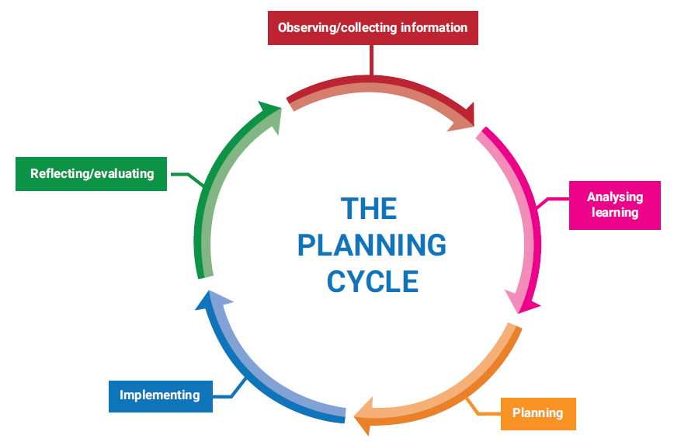
At Waratah School Preschool educators use the following observation and planning cycle to guide and support the provision of learning experiences that meet the needs and interests of the children.

Observing & Collecting Information
The initial collection of information related to a child’s current knowledge, skills and abilities, strengths and interests and culture are collected throughout the enrolment process. Educators initiate a meeting with all families to discuss the needs of their child and family preferences. Every family also completes an additional information form, which is the basis of planning for the first few weeks of the year. Family goals are revisited and reflected upon throughout the year, with a formal meeting being offered in Term 3.
Information on children is gathered through the following means;
- Spontaneous jottings/Summative assessments (Appendix A), which capture the whole child (humour, milestones, achievements) and their individuality, with the purpose of sharing these moments with families.
- Observations in the form of learning records (see Appendix B) and learning observations (Appendix C).
- Discussions with families, including formal parent teacher meetings and informal sharing. Personalised Learning Pathways (PLP’s) and Individual Education Plans (IEP’s) are developed in consultation with families for children of Aboriginal or Torres Strait Islander background and children with additional learning needs.
- Collaboration with external services such as NDIS, early childhood services, specialists, early intervention and specialist staff. Information is gathered through the planning of learning support meetings, phone calls and classroom visits. This information is recorded in meeting minutes, educator diaries and communication plans.
- Transition to School statements
Educators are mindful in ensuring that the information collected on each child is meaningful, relevant to the individual and can be used to inform future planning. Educators focus on developing a rapport with each child and family to gain a better insight and understanding of the child’s preferred learning styles, personality, culture and needs.
Analysing Learning
Learning observations are analysed on the learning record template, with links to the EYLF made clear by highlighting the outcomes being addressed. An individual goal template (Appendix D) is used to record SMART (Specific, Measurable, Achievable, Relevant, Timed) goals based on aspects of a child’s learning and development that have been identified as areas for growth.
Planning
The Early Years Learning Framework is used as the basis for planning. Future directions, experiences and goals are based on the analysis of jottings, observations of children’s learning and through communication with parents and external agencies. Current affairs impacting on the children, families and the wider community also inform our planning.
The following templates outline planned experiences;
- Weekly planning outline (Appendix E)
- Weekly planning focus (Appendix F)
These templates outline the weekly focus based on children’s interests and questions, planned activities, expected outcomes, children involved, resources required and any planned events, such as evacuation drills, celebrations etc.
Implementing

Educators use the curriculum to support children’s learning and wellbeing, including routines, transitions, interactions, indoor and outdoor environments, group projects and investigations.

Each day the following opportunities are provided:
- Planned experiences based on children’s interests
- Intentional teaching (literacy, numeracy, music, interventions – linked to goals)
- Whole group/Small group learning (stories, singing, drama)
- 1:1 interaction with educators (planned and spontaneous)

The physical environment, both indoors and outdoors, is valued by all educators as a vital part of our program and enhances children’s learning and wellbeing. We place enormous value on the environment as ‘The Third Teacher’ (Loris Malaguzzi), as reflected in our service philosophy.

- Routines are viewed as rituals; ensuring that an everyday routine such as reading a story to a child, is turned into a meaningful moment of sharing and connecting with a child through a shared, collaborative experience. Routines are fluid and flexible and educators are responsive to the spontaneous interests and opportunities that present themselves throughout any given day.
- Transition periods are valued as opportunities for intentional teaching.
- Long periods of uninterrupted play is planned for during each day, both in the indoor and outdoor environment.
- Children are encouraged to make choices, request resources, which are readily available and are given time to revisit, repeat, consolidate, master and extend their learning.
- Educators engage with children and support them in their play and are mindful as to when to offer support and when to continue observing; referring to strategies such as OWLing (Observing Waiting Listening).

Reflecting and Evaluation
Waratah Public School Preschool engages in a cycle of continuous improvement. Educators critically reflect on their programming for individual children, small groups and whole group experiences during weekly staff meetings and informal discussions, evaluating all experiences and engaging in the self-reflection of practices. The reflection process involves asking questions such as;
- Were the expected goals/outcomes met?
- Did the experience enhance outcomes for the child?
- Is there another way to deliver the experience?
- Was it meaningful for the child/ren?
- Why didn’t it work?
Evaluations and reflections are recorded on weekly programming sheets and educator diaries. Educators reflect on the principals and practices of the EYLF and their personal biases and practices for children, in the form of a personal journal. Evaluations and reflections highlight the need for additional professional learning to address the needs of the children attending our preschool.
Documenting Learning
Educators makes learning visible to children, educators and families and promotes shared learning and collaboration (Guide to the National Quality Framework, Section 3, Quality Area 1). At Waratah Public School Preschool, we document children’s learning in the following ways.
- Photos (via text, iPad, email)
- Jottings (summative assessment)
- Facebook (closed group – families only)
- Portfolios (collection of work samples chosen by the individual child)
- Wall displays (investigations and projects etc.)
- Recordings (videos)
- Class Dojo (individual sharing platform)
- Samples of children’s drawings and paintings.
- Samples of children’s own writing, scribbles and representations
- Sticky notes
- Running records of events
- Checklists
- Lists of words/word banks
- Sketches
- Transcripts of conversations
- Ratings scales (ECERS, SSTEW)
Weekly programs are available for parents and caregivers to view and provide feedback on and we encourage input to the program from our families.

Assessment
Children’s individual goals are reviewed and adjusted throughout the year according to each child’s progress. An Individual Observation Tracking Sheet (Appendix G) is completed for each child; educators record learning observations towards achieving the EYLF outcomes and use this information to forward plan.
In Term 4, educators complete ‘Transition to School Statements’ and this is shared with families and schools in which the child will transition to (with parental permission).

References

Rituals: making the everyday extraordinary in early childhood - (ECA)

The Hanen Centre – OWLing

Appendices
APPENDIX A – Jottings/Summative Assessment

APPENDIX B – Learning Record
APPENDIX C – Learning Observation

Appendix D – Individual Goal Template

Appendix E - Weekly planning outline

Appendix F - Weekly planning focus

Appendix G – Individual Observation Tracking Sheet

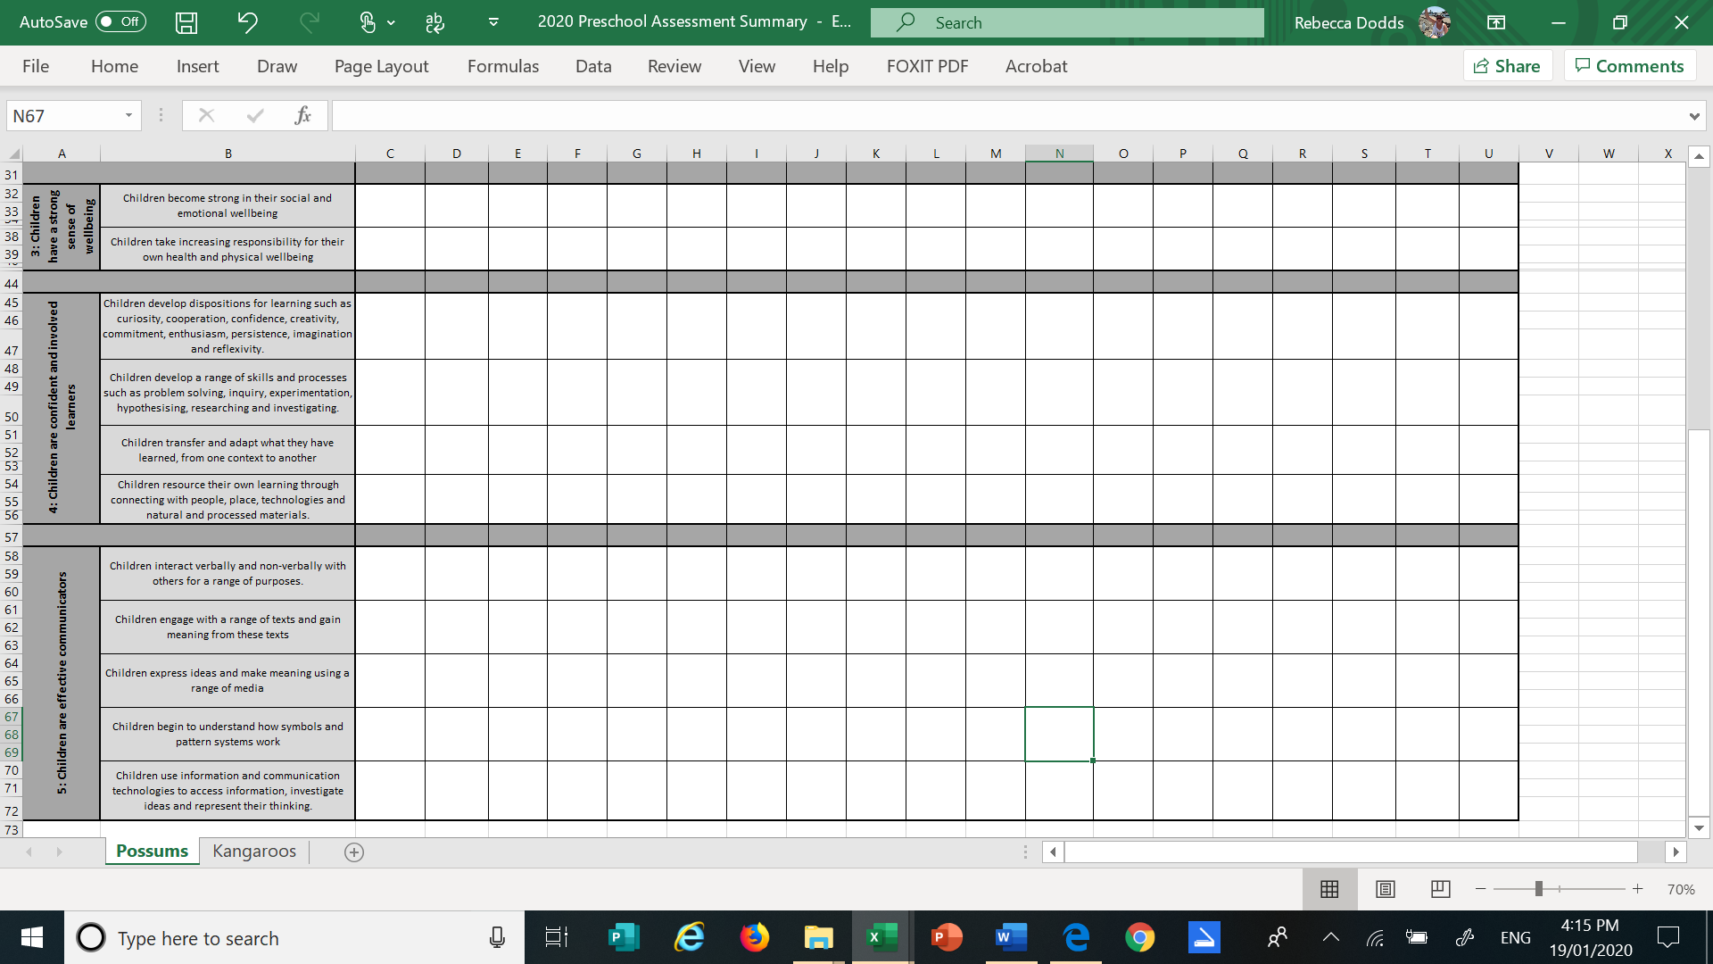
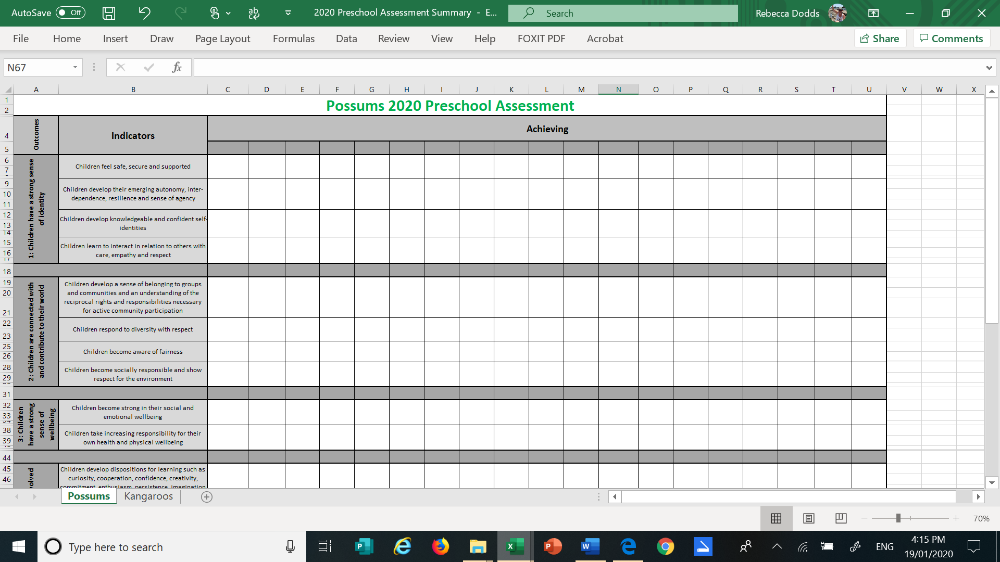
Appendix H – Class Tracking sheet

