Waratah School

Student Enrolment

Procedures and Protocols
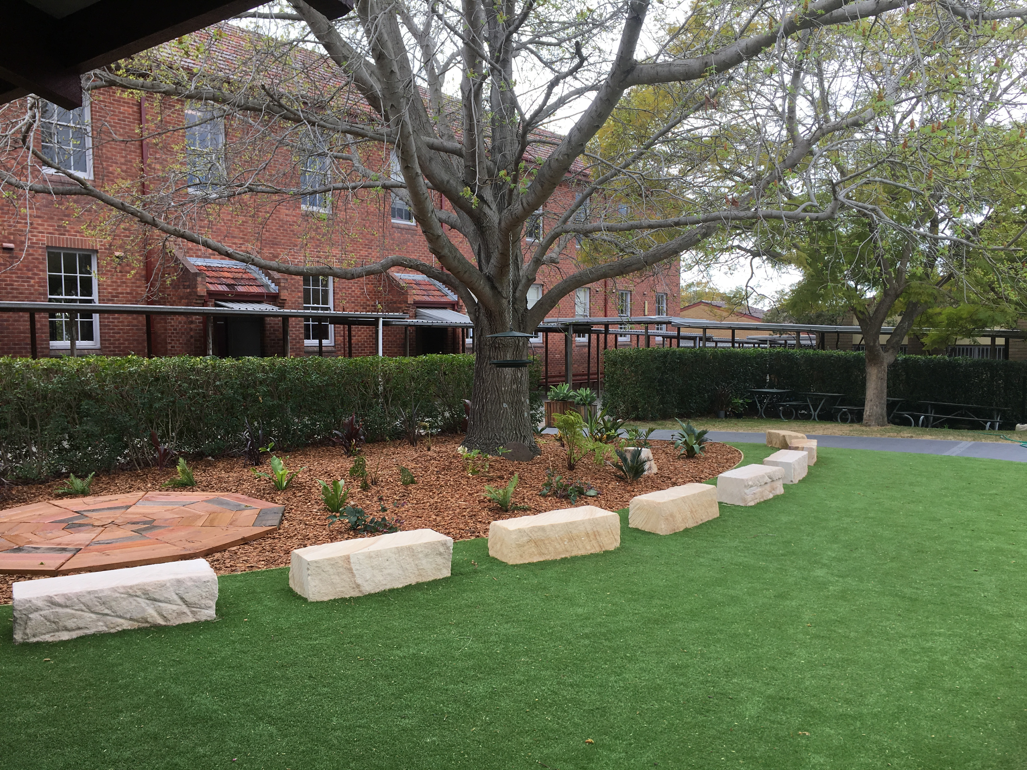
Contents
Document History 2
Synopsis 3
Managing enrolments in schools 3
Local Enrolment 3
Residential address check 4
Enrolment cap 5
Enrolment Buffer 5
Non-local enrolment 5
Criteria 6
Enrolment Panel 6
Enrolment time frame 6
Appeals 6

Document History
Version | Author | Date
1.0 | Mr Ricki Metcalfe | 11.09.19

Synopsis
This document supports Waratah Public School’s implementation of the NSW Department of Education’s Enrolment of Students in NSW Government Schools Policy (July 2019) and should be read in conjunction with the General Enrolment Procedures.

Managing enrolments in schools
A student is entitled to enrol at the local school that the student is eligible to attend if their home is within that school’s local intake area. Parents may apply to enrol their child in the school of their choice. Acceptance is subject to the child being eligible to attend and the school can accommodate the child. (General Enrolment Procedures: 9)
Parents may enrol a child if they turn 5 years of age on or before 31 July in that year. Students identified as gifted and talented, who are aged 4 years or older at 31 January of the year of enrolment may only be enrolled in accordance with the Gifted and Talented policy. (General Enrolment Procedures: 2)

Local Enrolment
To determine if a student’s home is within a school’s local intake area please use the School Finder App by clicking on the button below.

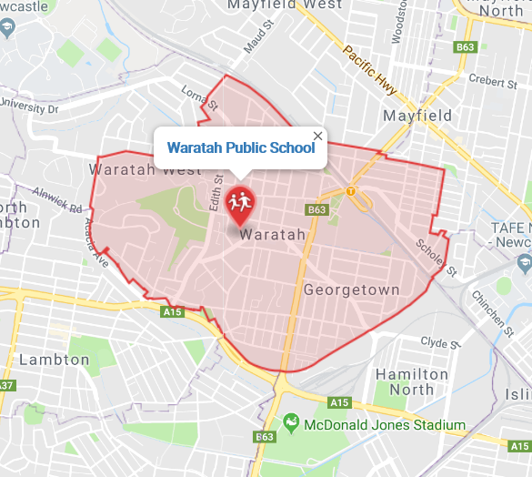

School Finder App

Residential address check
Under the Education Act 1990, principals may require proof of address to their satisfaction in order to establish a child’s entitlement to enrol in the school. However, any requests for proof of address must be reasonable in the circumstances. Schools that are at or nearing their local enrolment buffer as calculated in accordance with sections 9.1 and 9.2 will use the following 100-point residential address check to determine the student’s entitlement to enrol at the school.

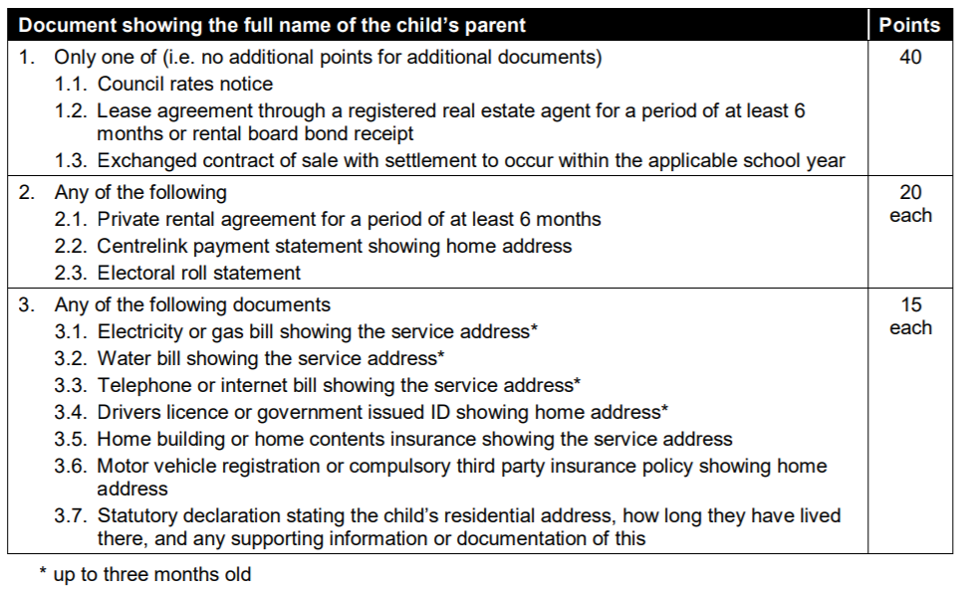

NB: Where a parent is able to give good reasons why they are unable to present documents, or in exceptional circumstances, principals may waive or vary the 100-point residential address check NSW Department of Education | PD/2002/0006/01/v1.0.0 10 requirements when assessing a child’s entitlement to enrol at the school. If this is to occur, principals are required to seek the approval of the Director, Educational Leadership.

Enrolment cap
Enrolment cap
Buffer level
Enrolment
The Enrolment Cap for a school is established centrally based on permanent accommodation.
(General Enrolment Procedures: 9.1)

Local enrolment buffer
Within the enrolment cap, a number of enrolment places (the buffer) must be set aside for the enrolment of local students arriving throughout the year. The size of the buffer will differ in each school based on historical data, enrolment fluctuations and on the number of families moving into or out of the area. The size of the local enrolment buffer is set locally by the principal and approved by the Director, Educational Leadership.
It is reviewed annually and set in time for assessing applications for the following year’s enrolment intake. Places in the local enrolment buffer are not to be offered to non-local students. (General Enrolment Procedures: 9.2)

Non-local enrolment
Non-local enrolment applications are only considered by schools that can accommodate the child below the set local enrolment buffer level. (General Enrolment Procedures: 9.4)
Except for enrolments at the commencement of the school year, schools that have not reached their local enrolment buffer level should only accommodate non-local enrolments into classes with available places. (General Enrolment Procedures: 9.4)
Non-local enrolment applications include the Application to enrol in a NSW Government school and a non-local enrolment application form. The non-local enrolment application form is developed by the school and requires the applicant to address the selection criteria and provide supporting documentation. (General Enrolment Procedures: 9.4.1)

Criteria
The criteria, listed below, for the enrolment of non-local students has been developed by the Principal, Mr Ricki Metcalfe, after consultation with the school community. (General Enrolment Procedures: 9.4.2)

- Siblings already enrolled at the Waratah Public School
- Medical reasons
- Safety and supervision of the student before and after school
- Student welfare needs
- Travel arrangements and/or distance
- Change of residence

Enrolment Panel
When demand for non-local enrolment exceeds the number of places available below the local enrolment buffer the school will establish an Enrolment Panel to consider all applications against the above criteria. (General Enrolment Procedures: 9.4)

1 | School Executive - Chairperson
2 | Staff member nominated by the Principal
3 | School community member nominated by the school’s parent organisation

Waiting lists
A waiting list may be created for non-local students who are not offered enrolment. Any waiting list created will remain valid during the current intake period only. The waiting list is determined by the enrolment panel. Parents are advised in writing if their child is to be placed on a waiting list and his or her position on it. The length of the waiting list should reflect realistic expectations of potential vacancies. (General Enrolment Procedures: 9.4.4)

Enrolment time frame
It is anticipated that enrolment of students should not exceed 10 days from receipt of completed Application to Enrol in a NSW Government School. Where circumstances indicate that this timeframe may not be met Principals are required to consult their Director, Educational Leadership.

Preschool Enrolment
Children can enrol from the beginning of the school year if they turn four years of age on or before 31 July in that year.
The principal will offer enrolment in the following order:
I. to children living within the school’s enrolment catchment area with priority given to Aboriginal children and those who are disadvantaged
II. to children living outside the school’s enrolment catchment area and who have siblings enrolled in the school, with priority given to Aboriginal children and those who are disadvantaged
III. to children living outside the local school’s enrolment catchment area with priority given to Aboriginal children and those who are disadvantaged.
Parents enrolling non-local children in preschool classes are reminded that acceptance into a preschool class does not guarantee acceptance for Kindergarten next year.

Appeals
Unsuccessful non-local applicants may appeal against the decision of the enrolment panel. The appeal is made in writing to the principal and sets out the grounds of the appeal. If necessary, the principal should provide or arrange assistance, such as an interpreter, to enable the appeal to be set out in writing. The purpose of the appeal is to determine whether the stated criteria have been applied equitably. If the principal is not on the enrolment panel, the principal considers the appeal and makes a determination. Otherwise, the appeal may be determined by the Director, Educational Leadership. (General Enrolment Procedures: 9.4.5)

Enrolment application decision tree

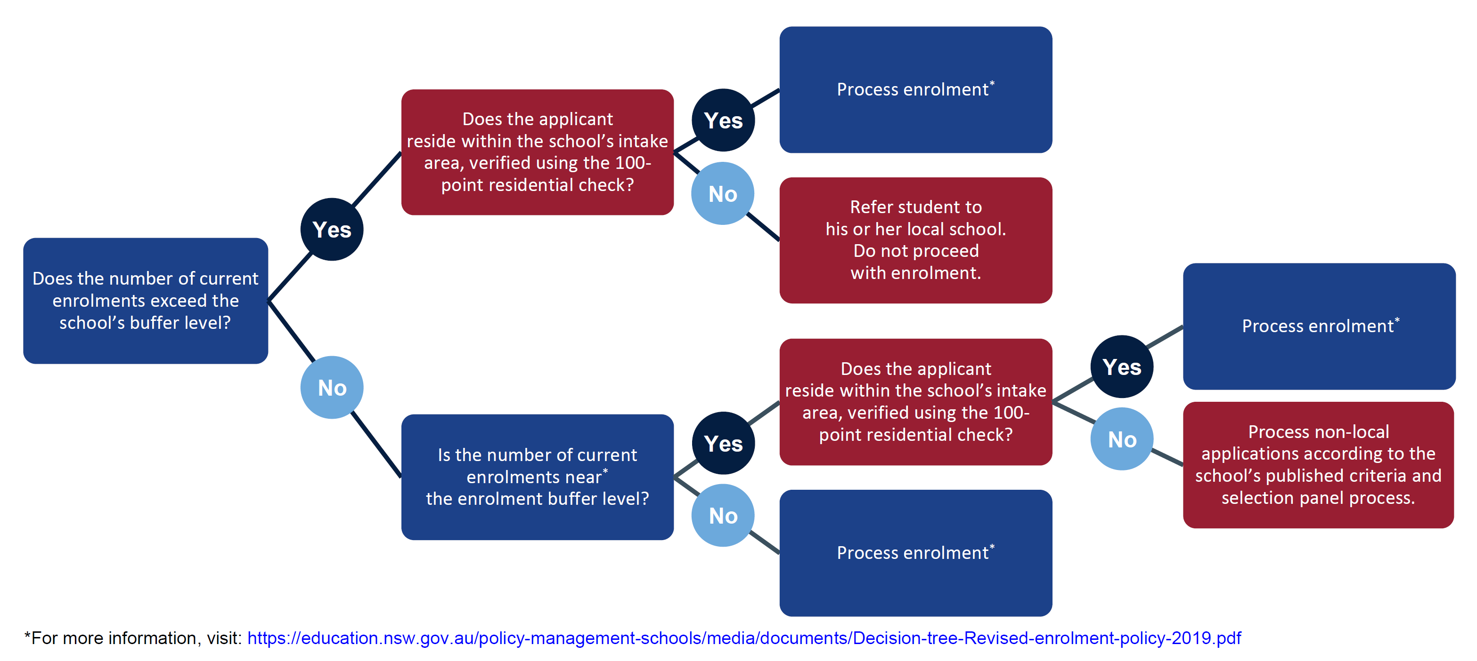

Director’s Endorsement

School | Waratah Public School
Year | 2019
Enrolment Cap | 531
Buffer | 495
Approaching Buffer – Non Local Enrolments requiring Director approval.
When the school’s enrolment level is close to the local enrolment buffer, the principal is required to inform the principal of the child’s local school when considering the non-local enrolment application, and to seek approval of the Director, Educational Leadership before making an offer to enrol the child.

I confirm my endorsement of the figures identified above.

Signature: ____

Josie Bailey
Director,
Educational Leadership
Callaghan Network

September 2019

